**Practical 08 Configure TELNET and SSH in Packet Tracer.**

Step 1 : First take one router four and end devices ( pc or laptop ) and set proper connections among them and Set IPs on the PCs.

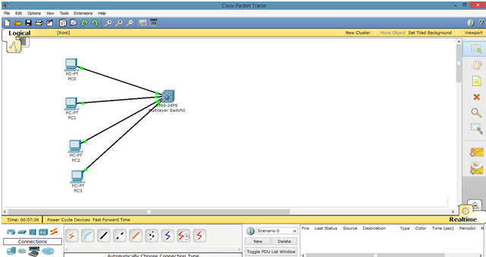

Step 2 : As, by default, all PCs are in vlan 1. We will create a virtual interface on switch with vlan 1 as follows.

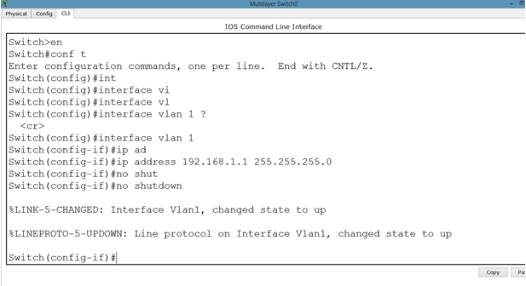

Step 3 : Now, we can ping to switch by our hosts because hosts are in vlan 1 and switch also has a vlan 1 interface.

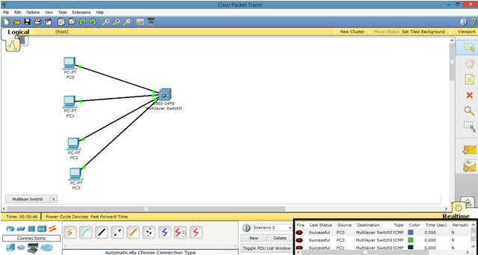

Step 4 : lets apply line authentication on the switch. The system supports 20 virtual tty (vty) lines for Telnet, Secure Shell Server (SSH) and FTP services. Each Telnet, SSH, or FTP session requires one vty line.

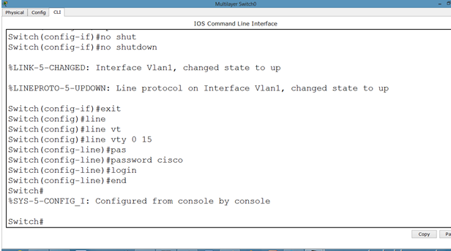

Step 5 : Lets apply password on the switch enabled mode.

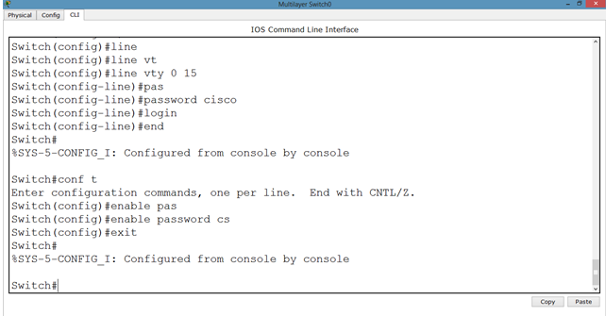

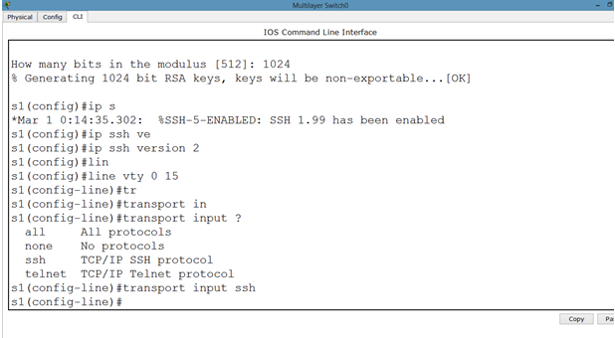

Now, we can change the username from admin to something else.